Safe systems of work
Tool box talk

CONFINED SPACE ENTRY
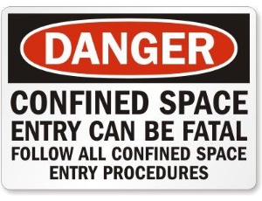

- Only trained, competent and authorized personnel may enter a confined space.
- All covers must be removed to allow for maximum ventilation 1 hour before work commences.
- Oxygen levels at 21 % must be checked & constantly monitored immediately before entry & during the work process.
- Vapor levels at 0 % must be checked & constantly monitored immediately before entry & during the work process.
- If oxygen levels cannot be maintained or realized then entry is forbidden & work must stop until satisfactory levels are reached.
- The emergency plan must be clearly understood by the working party before entry.
- Intrinsically safe equipment if flammable vapors are present or suspected must only be taken into the confined space.
- The permit to enter must be completed by an authorized & competent person.
- The correct PPE must be worn at all times.

If in doubt do not enter.

ALWAYS WORK SAFELY

The tool box talk is a short reminder of the pertinent facts involved in the process. It should be used as a refresher for all employees involved in the process. It is not a replacement or substitute for initial detailed safety training.

The date and names of those who have received the tool box talk should be recorded on the reverse of the documentation and signed by those attending.

This form should be retained by the H&S department for future managerial auditing purposes.

