Safe systems of work
Tool box talk

PERSONNEL PROTECTIVE EQUIPMENT (PPE)
BST STANDARD

1. SAFETY BOOTS
2. HI VISIBILITY VEST CLOTHING
3. SAFETY HELMET
4. SAFETY GLASSES

Main risks

1.Exposure to identified hazards

Safe Procedure
- Always ensure your PPE is correctly fitted and serviceable.
- Ensure you use your PPE according to your training and manufacturer’s details and instructions.
- Report any faulty equipment or defects.
- Ensure all used PPE is disposed of correctly.
- Always store your PPE correctley.

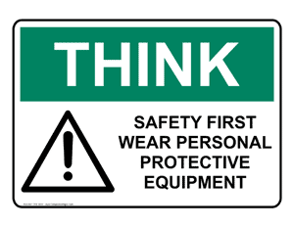
All PPE remains the property of the company and must be signed for upon receipt and returned when completed.

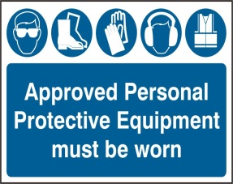
ALWAYS WORK SAFELY

The tool box talk is a short reminder of the pertinent facts involved in the process. It should be used as a refresher for all employees involved in the process. It is not a replacement or substitute for initial detailed safety training.
The date and names of those who have received the tool box talk should be recorded on the reverse of the documentation and signed by those attending.
This form should be retained by the H&S department for future managerial auditing purposes.

