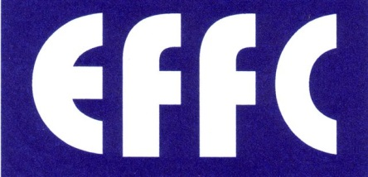
EUROPEAN FEDERATION OF FOUNDATION CONTRACTORS
Forum Court, Office 205
Devonshire House Business Centre
29-31 Elmfield Road
Bromley
Kent
BR1 1LT

Tel: + 44 20 8663 0948 Email: effc@effc.org
Website: www.effc.org

Dispute resolution / Sweden
The great majority of disputes in the construction industry in Sweden are settled by arbitration in accordance with the Swedish Arbitration Act.
According to the General Conditions of Contract, AB92, for the building and civil engineering and building services, such a procedure is applicable if not otherwise agreed between the parties.
Procedure:
A dispute will be settled by arbitration if both parties agree or if the contract contains and arbitration clause and one party demands that the dispute shall be settled in this way.
The arbitration tribunal consists of three members. Each party appoints one arbitrator and those two appoint the third, who will be the chairman. If a party neglects to appoint an arbitrator or if the two elected cannot agree on the third, the court will make an appointment. Unless the parties to the dispute agree otherwise, the arbitration award will be given within six months from the date of submission to arbitration - provided both parties are domiciled in Sweden.
The loosing party will bear the costs of the arbitration.
It is not possible to appeal against an arbitration award. However, it is possible to get the award reversed if the arbitration tribunal commits a major error.

