EUROPEAN FEDERATION OF FOUNDATION CONTRACTORS
Forum Court, Office 205
Devonshire House Business Centre
29-31 Elmfield Road
Bromley
Kent
BR1 1LT

Tel: + 44 20 8663 0948 Email: effc@effc.org
Website: www.effc.org

Analysing accidents

Analysing accidents
Basic Principles
Effective accident prevention relies to a great extent on a good understanding of on-site hazards which allow a proper risk assessment to be made and effective prevention measures to be put in place. Although some hazards are obvious, other incidents may appear to be isolated 'one-off' occurrences that could be attributed to bad luck. However, if it can be shown that such incidents are a typical of a certain system, greater attention can be paid to the particular characteristics of the system that might contribute to the risk.

Many foundation contractors are small companies. For a small company, in particular, it can be difficult to obtain a real appreciation of the frequency of accidents associated with particular work places or systems. If the only data that is available comes from the company's own accidents then it may take many years before sufficient data is available to analyse trends or to understand all the possible risk factors. Since each piece of data represents an injured person, it is important that every opportunity is taken to learn from other companies.

One of the major tasks of the EFFC Safety WG therefore, has been the development of a tool to collect accident reports from foundation companies and analyse them in a systematic and timely manner to provide an essential aid for accident prevention work.

Since 1995 numerous member companies of the national EFFC partner organisations have provided information on every accident occurring on their premises or on their sites. Participation in this program is on a voluntary basis and the information provided remains anonymous.
For this purpose a report sheet has been prepared which has spaces to tick or enter information on the following issues:-
- Time of accident
- Duration of shift
- Age and occupation of the injured person
- Place of the accident
- Injuries
- Activity carried out at the time of the accident
- Accident description.
It is a requirement in all European Countries to report accidents to the relevant authority. However there is a huge variety of forms, using variety of definitions and formats. Moreover these forms are often designed, not for construction alone, but for every industrial sector. Even if the form is just for construction, it covers all construction activities. The EFFC form is specific to foundation and other geotechnical work. It is an easy check-box format and covers those activities and hazards which occur on foundation sites. It can therefore be used by companies to undertake their own detailed analyses of their own accidents, and if data is submitted to the EFFC, it can be analysed to identify industry wide trends that may otherwise not be obvious.

Review
Over 3500 industrial accidents have been reported, all of which occurred during geotechnical and foundation works in 13 European countries. These accident reports provide an extensive and reliable database, from which reliable conclusions can be reached on the causes of accidents in this. Furthermore, this database provides useful information, from which target-oriented measures can be deduced to minimise risks and reduce the accident rate and severity.
Reports on the survey results were published in several national and international publications.

Examples of analysis results
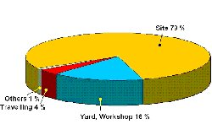
The results show that 16% of accidents occurred in the workshop and contractor's yard. This means that activity involving manual handling like repair and maintenance work represents a key accident hazard and deserves special attention when planning preventive measures.
Accident Description
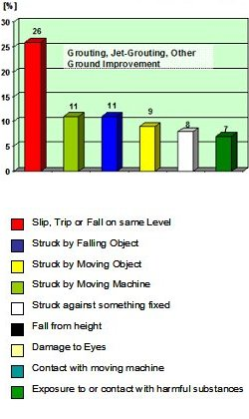
The evaluation of accident occurrence according to sector of activity shows which key accident risks shall be emphasised. The high rate of accidents from "slipping, tripping or falling on same level" during grouting work indicates the necessity for greater attention to be awarded to the safe design and maintenance of walkways and access means.
The previous analysis led to interesting results, which have been implemented in different ways. For instance, the key accident hazards during anchoring work have been clearly demonstrated and can be reduced through technical measures. The findings of the EFFC accident analysis provide reliable evidence concerning equipment that can be incorporated into the European safety standards for "Drill Rigs" and "Piling Rigs".

In the future
The collection and analysis of data which commenced in 1995 should be strongly encouraged. The Safety WG of EFFC decided therefore to redesign the EFFC report sheet to make it even more simple, to keep preparation work for the companies to a minimum and therefore increase the willingness to co-operate.

The EFFC's accident report form is specific to foundation and other geotechnical work.
Download the form here in:
Czech, Danish, English, French, German, Hungarian, Italian, Polish and Spanish
The more data we get, the more sound and realistic will be the results. The active participation in this EFFC Safety project will provide a statistical basis, which is essential for international projects but will also allow each company and national federation to set a benchmark.

We recommend that you grasp this chance

